# NOSQL

* NoSQL, or "Not Only SQL," refers to non-relational databases that store and retrieve data differently than traditional SQL databases. Unlike SQL's fixed, tabular format, NoSQL databases use various models like documents, key-value pairs, wide columns, or graphs to manage unstructured or semi-structured data. They offer flexible schemas, horizontal scalability for large datasets, and are well-suited for big data and real-time web applications.
* Key Characteristics
  + Non-Relational Structure: NoSQL databases don't use the rows and columns of relational tables but instead employ flexible data models like documents, graphs, key-value, or wide-column stores.
  + Schema Flexibility: They don't require a fixed schema, allowing them to handle dynamic and unstructured data without rigid predefined structures, according to IBM.
  + Scalability: NoSQL databases are designed for horizontal scaling, meaning they can handle vast amounts of data by distributing it across multiple servers.
  + Performance: Their design is optimized for speed and performance, making them efficient for tasks like data retrieval.
  + Distributed: Many NoSQL databases are distributed, storing data copies across various servers to ensure high availability and reliability.
* When to Use NoSQL
  + Big Data: Ideal for managing massive and rapidly growing datasets.
  + Real-time Web Applications: Their scalability and performance are critical for applications requiring high-speed data access.
  + Unstructured Data: Perfect for storing data that doesn't fit neatly into traditional relational tables, such as documents, social media feeds, or sensor data.

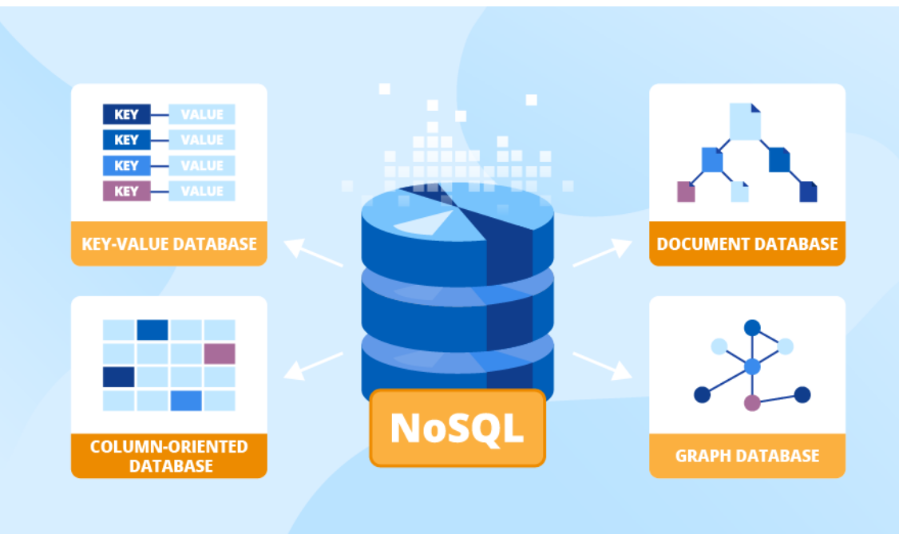

### Real World Usecases:

* Retail
  + Personalized Recommendations:
    - NoSQL databases manage diverse product catalogs and customer interactions to power real-time, personalized recommendations.
  + Customer 360 View:
    - They capture large amounts of omnichannel customer interaction data and link it to individual accounts, creating a comprehensive customer profile.
  + Inventory Management:
    - NoSQL databases' flexible nature and ability to handle complex data are well-suited for managing dynamic inventory information.
* Banking
  + Fraud Detection:
    - Graph databases, a type of NoSQL, are used to analyze transaction paths and user connections to detect suspicious patterns and money laundering.
  + Customer Data Management:
    - They help manage vast quantities of data from multiple sources, enabling banks to offer personalized services and support.
  + High-Availability Systems:
    - NoSQL databases provide the high uptime and data redundancy required for essential banking operations.
* Social Media
  + User Data Management:
    - NoSQL databases can store and query massive amounts of unstructured data, including user profiles, posts, and interactions, with low-latency access.
  + Real-time Analytics:
    - Their scalability is crucial for platforms handling unpredictable, high-volume workloads, enabling real-time data analysis.
  + Content Management:
    - The schema-free design of NoSQL databases is perfect for managing dynamic and evolving content structures on social platforms.
* Education
  + Content Management Systems:
    - NoSQL databases are ideal for managing varied and polymorphic content structures in educational platforms, allowing for dynamic content and flexible designs.
  + Student and Course Management:
    - They can handle large, diverse datasets, such as student records and course information, which may have flexible or evolving structures.
  + Personalized Learning:
    - The ability to store and query diverse student data makes NoSQL databases valuable for creating personalized learning experiences and adaptive content.